When Do You Need an OPG or Full Mouth X-ray at Butler Medical Imaging? (08) 9544 3999

[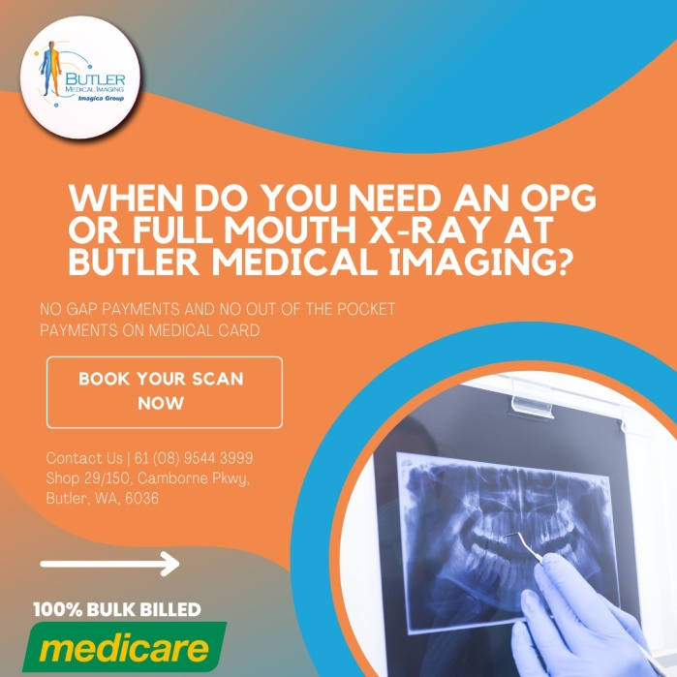](https://butlerimaging.com.au/appointment/)When we want to take a look at what's happening with our teeth, we typically use a mirror. However, a mirror can only show the surfaces of the teeth, not the details beneath the gum line or inside the teeth. This limitation means that even your dentist can't see everything with just a simple visual examination.

Fortunately, advancements in dental technology have introduced the Orthopantogram (OPG), also known as a full mouth [**dental X-ray**](https://butlerimaging.com.au/dental-xray-opg/). This technology makes the invisible details of the teeth visible, providing critical diagnostic information to dentists.

**What is an OPG or Full Mouth X-ray?**

An OPG is a sophisticated type of full dental X-ray that provides a wide-view image of the upper and lower jaws on a single film. It displays the position, number, and growth of all the teeth, including those that haven't surfaced above the gum line yet.

The [**OPG X-ray**](https://butlerimaging.com.au/dental-xray-opg/) produces a two-dimensional view of both the mandible (lower jaw) and maxilla (upper jaw). The images it generates are crucial for dentists to make accurate diagnoses and develop effective treatment plans.

**How Do OPG X-rays Work?**

The principles behind an OPG are similar to those of a basic X-ray. During the procedure, you rest your chin on a support in front of the OPG machine and bite on a sterile mouthpiece. You will be instructed to press your tongue against the roof of your mouth and remain still to ensure clear images are captured.

The OPG machine rotates around your head, taking a panoramic scan of your jaw. This entire process takes only a few seconds and is painless, making it a convenient and efficient [**diagnostic tool.**](https://butlerimaging.com.au/dental-xray-opg/)

**When Do You Need an OPG or Full Mouth X-ray?**

Early diagnosis is key to maintaining dental health and preventing more serious issues. An OPG or full mouth X-ray can help detect conditions in their earliest stages, allowing for timely intervention. Here are some scenarios where an OPG might be necessary:

1. **Fractures**: Detecting fractures in the jaw or teeth that are not visible through a regular examination.
2. **Cavities**: Identifying cavities that are hidden between teeth or under fillings.
3. **Tumors**: Spotting benign or malignant growths within the jawbone.
4. **Teeth Impaction**: Assessing impacted teeth, particularly wisdom teeth that haven't erupted properly.
5. **Jaw Dislocation**: [**Diagnosing dislocations**](https://butlerimaging.com.au/dental-xray-opg/) of the jaw that might not be evident through a physical exam.
6. **Infection**: Detecting infections in the teeth, roots, or jawbone that can cause pain or abscesses.
7. **Sinuses**: Evaluating issues related to the maxillary sinuses, which can affect dental health.
8. **Orthodontic Treatment**: Planning and monitoring orthodontic treatments, such as braces, to ensure teeth are moving correctly.
9. **Evaluate Wisdom Teeth Development**: Assessing the growth and development of wisdom teeth to determine if extraction is necessary.

**The Benefits of an OPG X-ray**

An OPG X-ray provides several advantages over traditional dental imaging methods:

* **Comprehensive View**: It offers a complete panoramic view of the entire mouth, including teeth, jawbones, and surrounding structures, enabling a thorough assessment.
* **Non-Invasive**: The procedure is non-invasive and quick, causing minimal discomfort to the patient.
* **Early Detection**: It allows for the early detection of [**dental issues**](https://butlerimaging.com.au/dental-xray-opg/), facilitating prompt treatment and better outcomes.
* **Pre-Surgical Planning**: Essential for planning complex dental procedures, such as implant placements, by providing detailed images of the jawbone.
* **Reduced Radiation**: Modern OPG machines use lower radiation doses compared to traditional X-rays, making them safer for patients.

**Getting an OPG or Full Mouth X-ray at Butler Medical Imaging**

At Butler Medical Imaging, we provide convenient OPG X-rays using state-of-the-art technology. Our skilled technicians ensure a comfortable and efficient experience, capturing clear and precise images for accurate diagnosis and treatment planning.

**Why Choose Butler Medical Imaging?**

* **Advanced Technology**: We utilize the latest imaging technology to deliver high-quality diagnostic results.
* **Expert Staff**: Our team of experienced [radiologists and technicians](https://butlerimaging.com.au/dental-xray-opg/) are dedicated to providing the best care.
* **Convenience**: We offer flexible appointment times to fit your schedule.
* **Patient-Centered Care**: Your comfort and well-being are our top priorities.

[**Your Next Step**](https://butlerimaging.com.au/appointment/)

To schedule an OPG or full mouth X-ray, contact us at Butler Medical Imaging. Bring your Medicare card and referral to your appointment. If you have any questions, feel free to call us at [(08) 9544 3999](https://butlerimaging.com.au/appointment/). We're here to help you maintain your dental health with the best diagnostic tools available.

**Conclusion**

An OPG or full mouth X-ray is an invaluable tool in modern dentistry, allowing for the early detection and treatment of a wide range of dental conditions. By providing comprehensive and detailed images of the entire mouth, it ensures that both patients and dentists have the information they need for effective dental care.